**Tutorial 4 ASE Assignment**

**Login page**

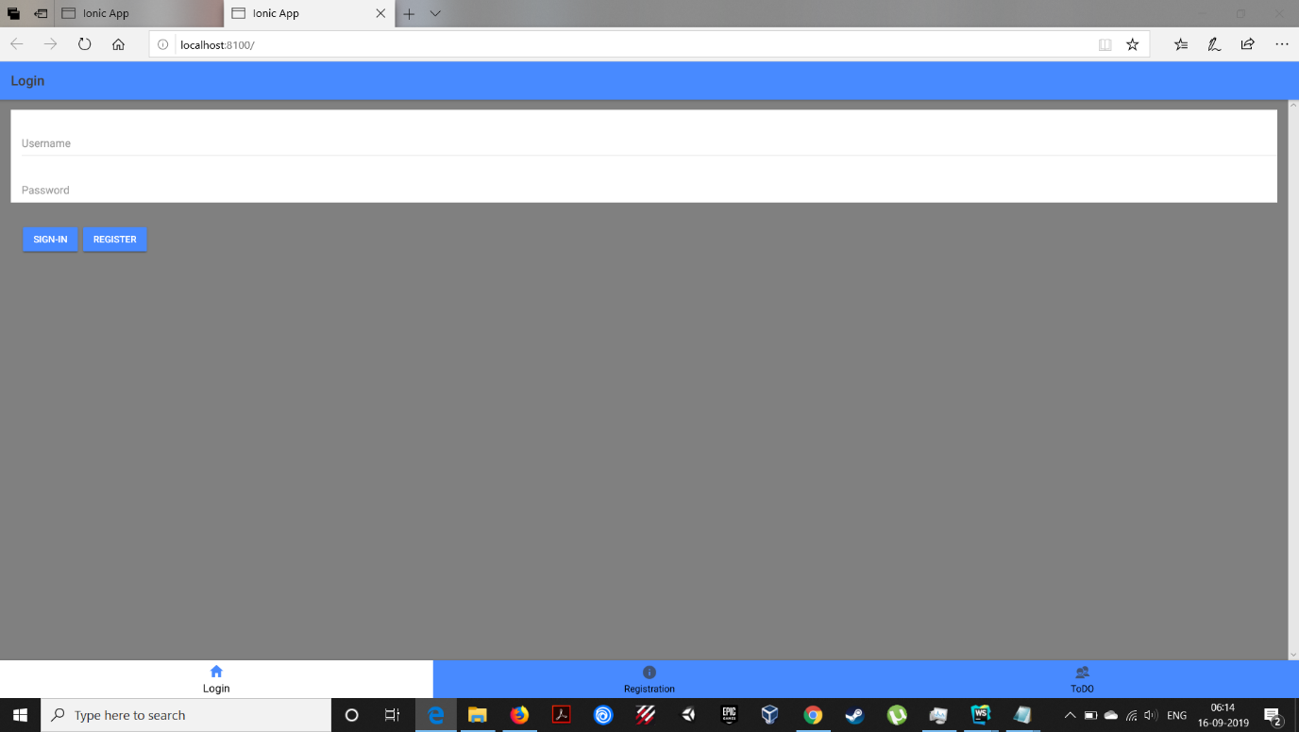

**Registration page**

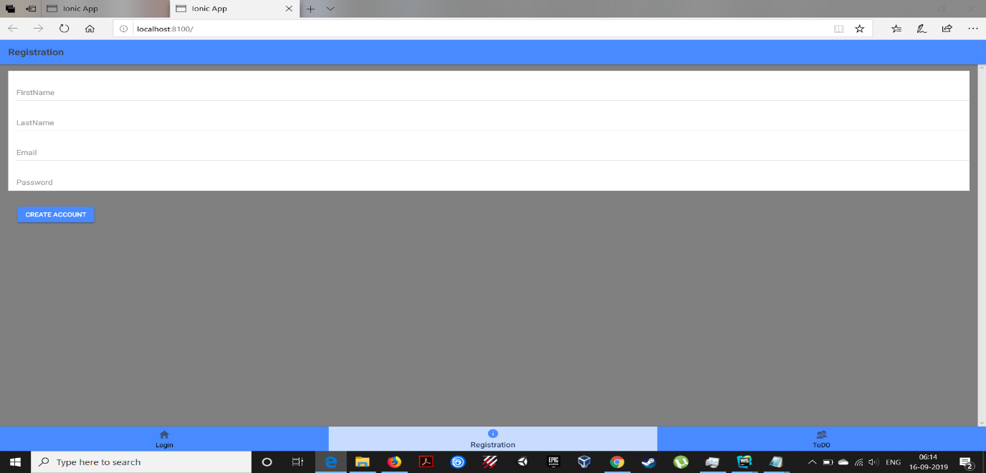

**ToDo page**

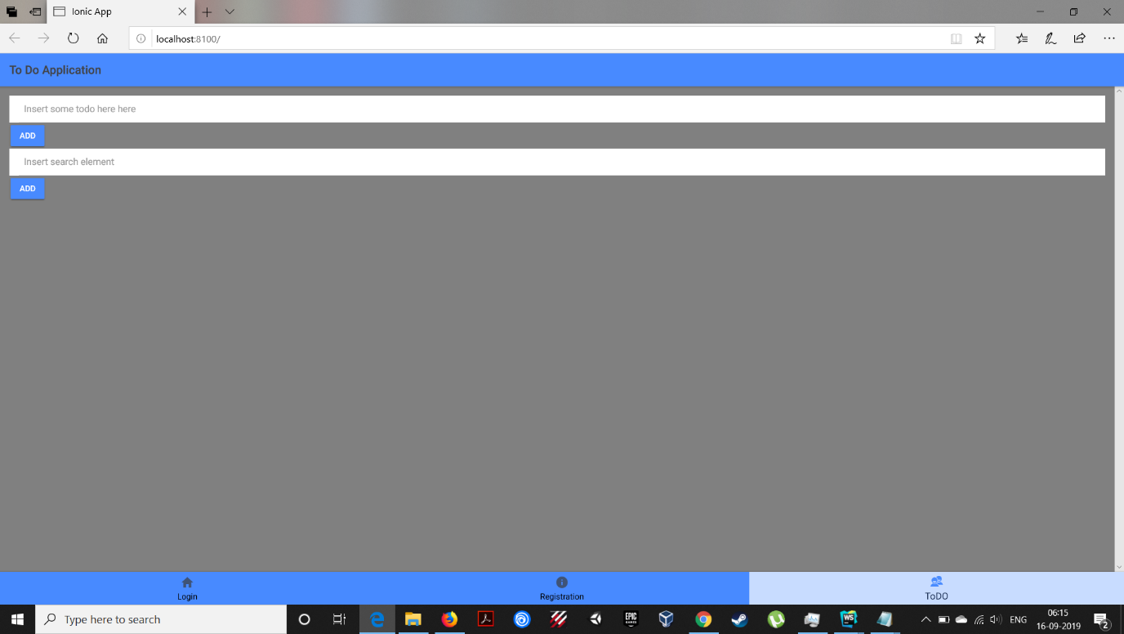

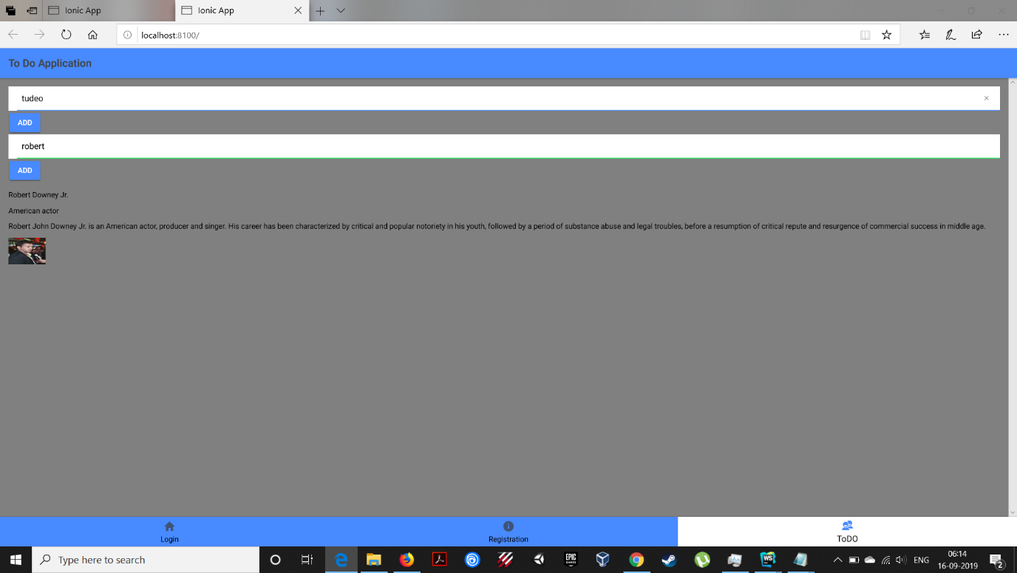

we have added Google knowledge based api . In which it returns the values of the person or thing according to its popularity. In the above case I have searched for Robert it returned me values of Robert Downey.

**Registration Page for testing** 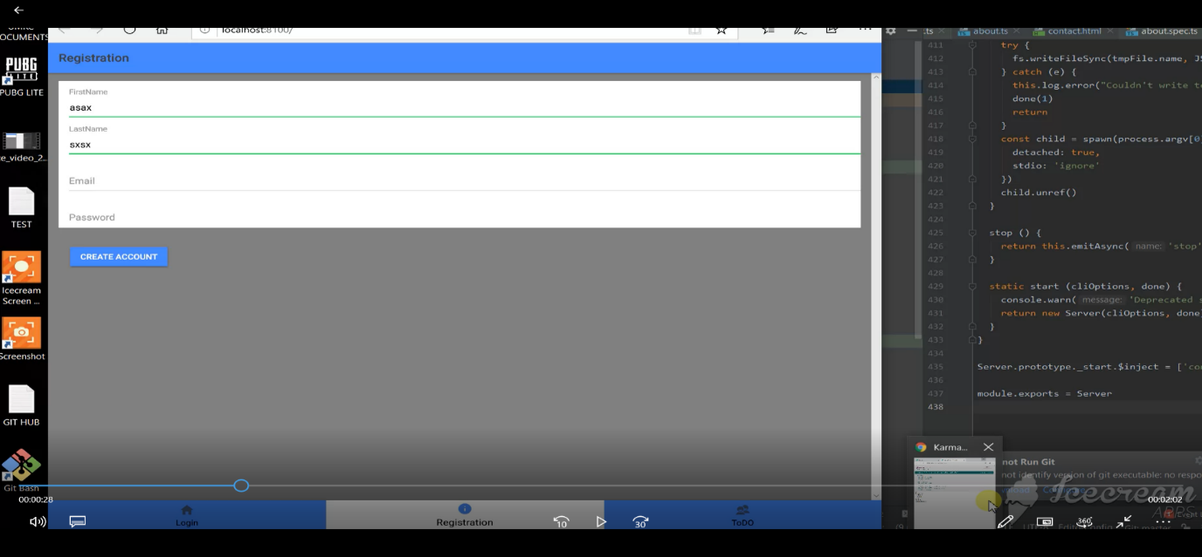

**Karmas Page**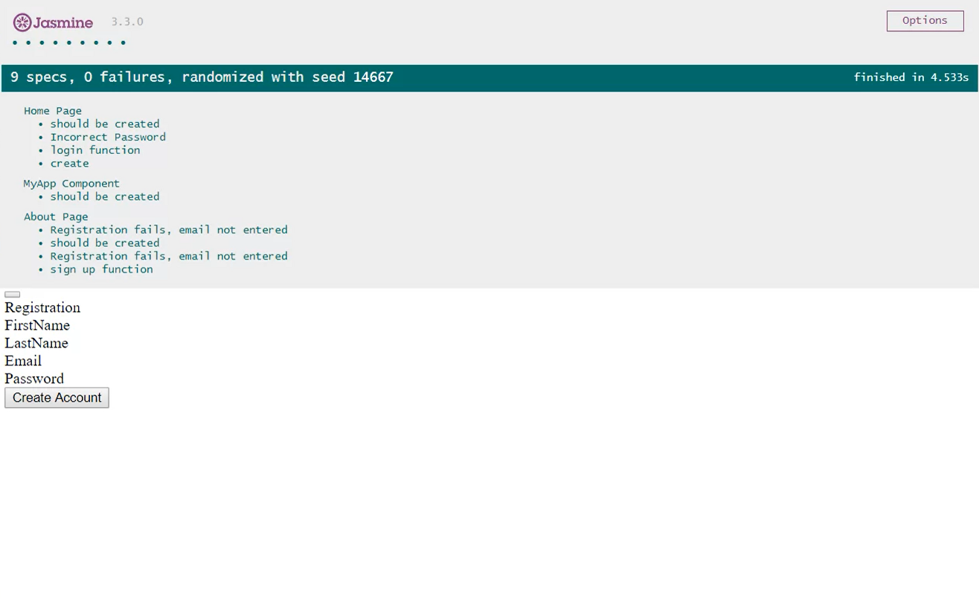

I have given three test cases for missing values in registration page and I have also given verification for user login page.

**Contribution:**

Frontend was done by Rod. Backend is done by Nithin

**by**

**Dukkipati, Sri Sai Nithin Chowdary(class id 05)**

**Skoglund, Rod (class id 23)**